Renju lesson on January 17, 2002

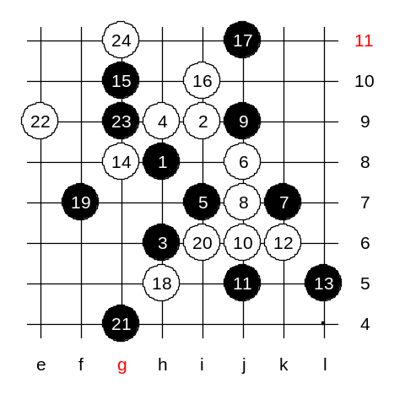
Hello everyone! Welcome to Online Renju Class. We continue with i10 today. Today we will check another 12th move. We will check the one that Nakamura used against me in the 4th game of the match. Nakamura played 12-k6. That move surprised me a bit. Actually, in usual situation I would play 13-L5 without a doubt. But game with Nakamura is not usual situation. I assumed, this is black win, and L5 is the best. But after seeing Nakamura playing this 12th move, made me unsure. So, I changed from L5 to safer i8. It was not fear, but cautiousness. I was in the lead in the match with 2:1, and there was no need to gamble. I assumed, black L5 and white’s g8 will lead to sharp position. And black would have to defend for a while. The outcome would still be very good for black, I thought, but yet I chose the safer plan. Which move shall we look first, L5 or i8? OK, I obey majority – we play L5 first. White will continue actively. If white plays defensively then black gets tempo, having a very good stones pattern. White goes g8. Now I assumed black must go g10. White has the tempo now. Although I could not see anything useful for white here, I still did not want to give Nakamura that initiative. White would likely continue to i10 – three. Can black block from lower side? Cannot, because white would win. Now, white continues to h5, perhaps. As you see, white is using the initiative to attack and defend at the same time. Where does black play now? Majority says f7. Ok. And after i6 you decided to block g4. Ok. As you see, black has all the pace and potential, but white has the tempo, and it can really be annoying. White can use the tempo to “fill up” the board. White 22nd move is dangerous. It threats the 3x3 in upper side. White continues to 24-g11. Well, don’t you have a feeling that although black has winning space below, black might never have a chance to enjoy it and lose before ever reaching to lower side.
Well, I am sure black can change something earlier. But it is a very troublesome variant. That is why I did not want to choose L5 in my game. In correct play after L5, black should be able to defend, and after having defended, black wins fast below. Agree?

Well, those who want to win as black using L5, should do preparation before game. Agree? I was not prepared to know all the correct defense steps, so I did not use L5. Shall we try the safe style now? Then, having both variants, each of you can decide which variant to use in games.

Move 13-i8 – safe style. There is only one move that can save white from loss. For example, why h7 is bad? Because of space. Move g6 takes some space away whereas h7 is too inside, and gives black g5 development. It is too logical, therefore we skip the h7 variant and continue with g6.
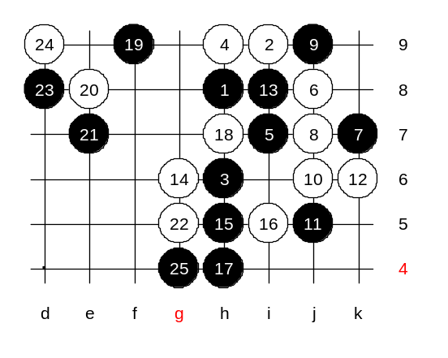
Move 19-f9 was a big surprise for Nakamura. He did not think this move was good, he said later. But actually the move turned out to be very good. The concept is hidden deep. Firstly, since lower side alone is not enough for win, any move there would be waste of source. Secondly, since black has nothing to do with tempo anyway, it is wise to give it away and make a good defense move instead. Third, the best defense move is the one that is most useful for self. But here is the hardest part. Many players cannot decide what is “good move for self”. Maybe active, maybe passive, maybe threat, maybe space move, maybe simple block instead, etc. Hard choice. But follow the rule – choose the move with the best outcome. To do that, you need to compare possible scenarios and outcomes on those. I went through some possible scenarios before playing that 19th move. I reached to the conclusion that defense and giving up tempo is the best for black. The advantage of the move: Black created new dangerous area and therefore does not give white any time to kill the lower side material. And assuming that white must block nearby anyway, it will be good trade off – black takes good point from white while white is forced to follow by placing a weak stone. E8 followed. Now black has reached total control – white has no place at all to create any activity. As you see, as long as black has some source and potential, there is no hurry to attack, and it is wise to secure position more. I played e7. It surprised Nakamura the most. It looks passive move but it is the best. My idea was to keep white under constant pressure having the lower side potential. At the same time I was trying to build towards upper space. And I tried to take maximum help from lower side source I could. Now, why e7 is good in this, let me explain. If white wants to kill the lower side source completely and play too low, then the e7 stone will walk around the e8 and bring black win. If white chooses to defend closer to e7 stone, as Nakamura did, then black can later use the lower side power again and again.
Let’s test what happens if white plays too low. Where? G5 ok. Black walks around e8 stone. We do not have time to finish this diagram. You can check it at home later. Black has many potential points, such as f10, c7, etc.

